TOPIC 4
Q1. Dice Throw Problem
Aim
To find the number of ways to obtain a target sum using a given number of dice.
Algorithm
- Create a DP array for storing ways.
- Initialize one way to get sum 0.
- Update ways for each dice throw.
- Print the number of ways for the target sum.
CODE:
num_sides = 6
num_dice = 2
target = 7

dp = [0]*(target+1)
dp[0] = 1

for _ in range(num_dice):
temp = [0]*(target+1)

for s in range(target+1):
for face in range(1,num_sides+1):

if s+face <= target:
temp[s+face] += dp[s]

dp = temp

print("Ways =", dp[target])

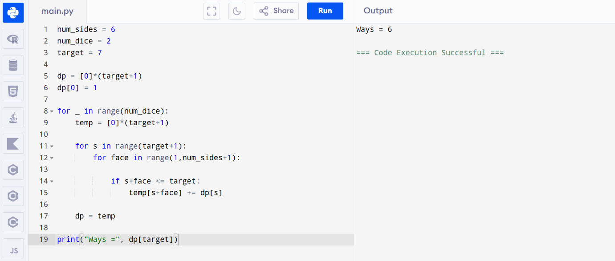

Result
The number of ways to obtain the target sum is found successfully.
Q2. Assembly Line Scheduling
Aim
To find the minimum processing time in a two-line assembly system.
Algorithm
- Initialize entry times.
- Calculate minimum time for each station.
- Consider transfer times between lines.
- Return minimum exit time.
CODE:
a1 = [4,5,3,2]
a2 = [2,10,1,4]

t1 = [7,4,5]
t2 = [9,2,8]

e1,e2 = 10,12
x1,x2 = 18,7

f1 = e1 + a1[0]
f2 = e2 + a2[0]

for i in range(1,len(a1)):

nf1 = min(f1+a1[i], f2+t2[i-1]+a1[i])
nf2 = min(f2+a2[i], f1+t1[i-1]+a2[i])

f1,f2 = nf1,nf2

print(min(f1+x1,f2+x2))

Question 3: Multi-Assembly Line Scheduling Problem
Aim
To determine the minimum production time for manufacturing cars using three assembly lines by considering station processing times, transfer times, and task dependencies using Dynamic Programming.
Algorithm
- Define the station times for all three assembly lines.
- Define the transfer time matrix between lines.
- Initialize the DP table with the processing times of the first station.
- For each subsequent station:
  - Calculate the minimum time required to reach that station from every possible line.
  - Add the transfer cost if switching lines.
- Store the minimum time in the DP table.
- After processing all stations, find the minimum value in the last station column.
- Display the minimum production time.
Python Program
def assembly_line_scheduling():
station_times = [
[5, 9, 3], # Line 1
[6, 8, 4], # Line 2
[7, 6, 5] # Line 3
]
transfer = [
[0, 2, 3],
[2, 0, 4],
[3, 4, 0]
]
lines = 3
stations = 3
dp = [[0] * stations for _ in range(lines)]
for i in range(lines):
dp[i][0] = station_times[i][0]
for j in range(1, stations):
for i in range(lines):
dp[i][j] = min(
dp[k][j-1] + transfer[k][i]
for k in range(lines)
) + station_times[i][j]
result = min(dp[i][stations-1] for i in range(lines))
print("Minimum Production Time =", result)
assembly_line_scheduling()
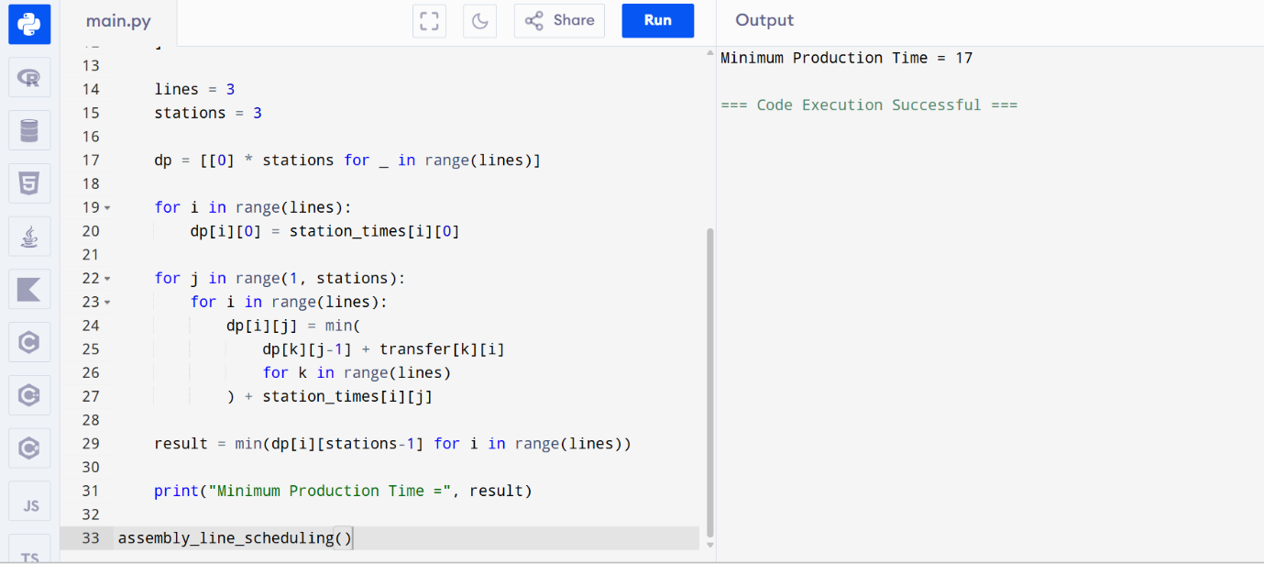
Result
Thus, the program to find the minimum production time for multiple assembly lines using Dynamic Programming was implemented and executed successfully.
Question 4: Minimum Path Distance Using Matrix Form (TSP)
Aim
To find the minimum path distance using a matrix representation of distances between cities by applying Dynamic Programming.
Algorithm
- Read the distance matrix.
- Use Dynamic Programming with bit masking.
- Start from city 0.
- Visit all cities exactly once.
- Return to the starting city.
- Compute the minimum travel cost.
- Display the minimum path distance.
Python Program
from functools import lru_cache
def tsp(dist):
n = len(dist)
@lru_cache(None)
def dp(mask, pos):
if mask == (1 << n) - 1:
return dist[pos][0]
ans = float('inf')
for city in range(n):
if mask & (1 << city) == 0:
ans = min(
ans,
dist[pos][city] +
dp(mask | (1 << city), city)
)
return ans
return dp(1, 0)
dist = [
[0,10,15,20],
[10,0,35,25],
[15,35,0,30],
[20,25,30,0]
]
print("Minimum Path Distance =", tsp(dist))
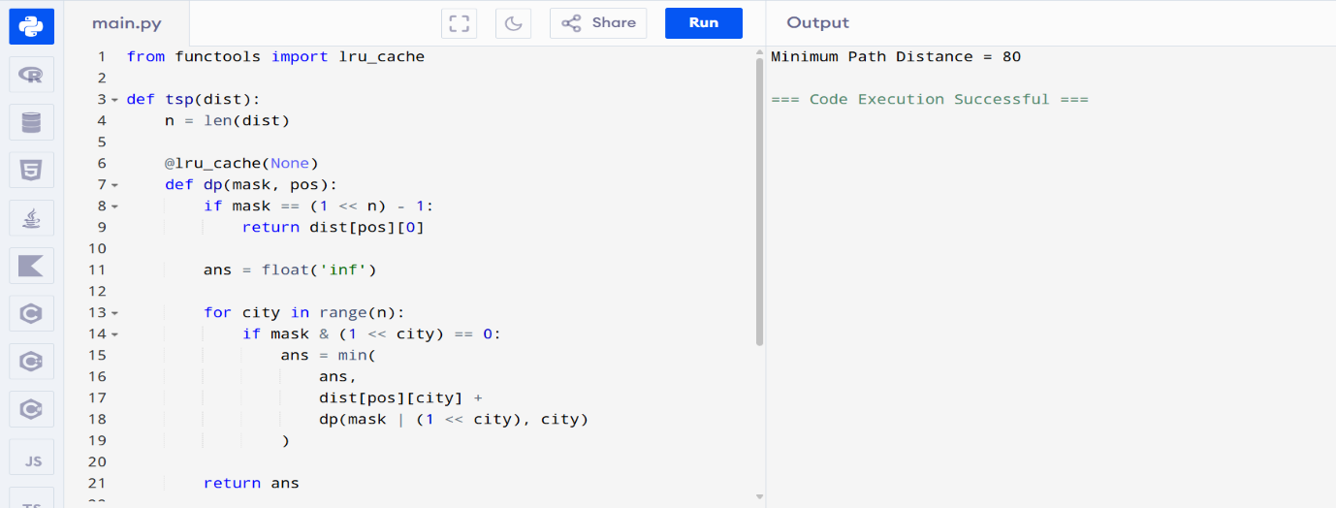

Result
Thus, the program to find the minimum path distance using Dynamic Programming and matrix representation was implemented and executed successfully.
Question 5: Traveling Salesperson Problem for 5 Cities
Aim
To find the shortest route and minimum distance for visiting all cities exactly once and returning to the starting city using Dynamic Programming.
Algorithm
- Represent the cities and distances in a matrix.
- Use Dynamic Programming with bit masking.
- Start from city A.
- Visit each city exactly once.
- Return to city A.
- Calculate the minimum route cost.
- Display the shortest distance.
Python Program
from functools import lru_cache
dist = [
[0,10,15,20,25],
[10,0,35,25,30],
[15,35,0,30,20],
[20,25,30,0,15],
[25,30,20,15,0]
]
n = len(dist)
@lru_cache(None)
def tsp(mask, pos):
if mask == (1 << n) - 1:
return dist[pos][0]
ans = float('inf')
for city in range(n):
if mask & (1 << city) == 0:
ans = min(
ans,
dist[pos][city] +
tsp(mask | (1 << city), city)
)
return ans
print("Shortest Distance =", tsp(1,0))
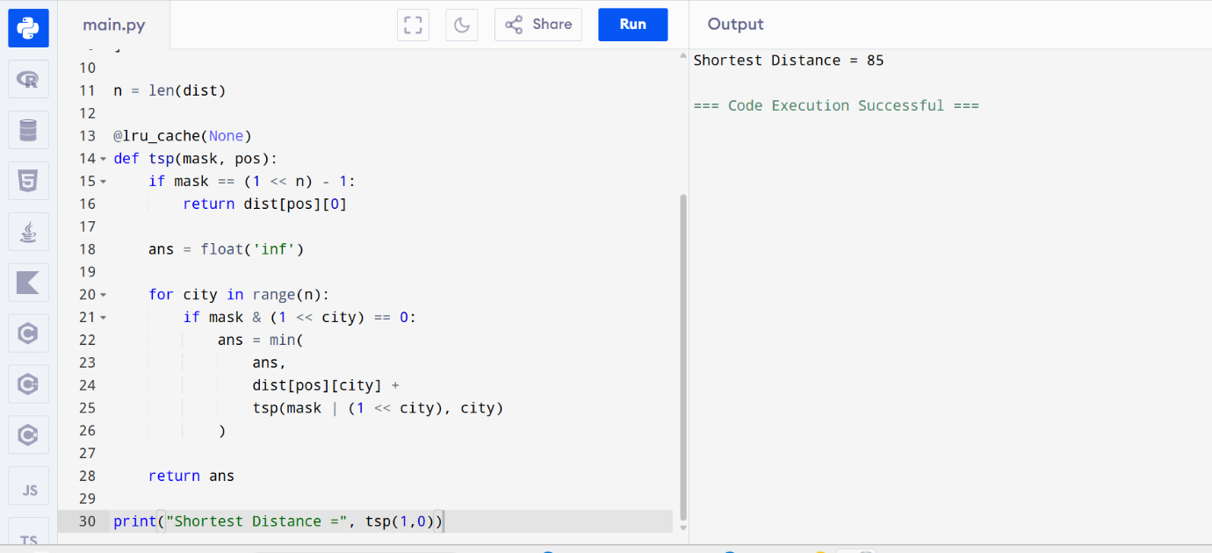
Result
Thus, the program to solve the Traveling Salesperson Problem using Dynamic Programming was implemented and executed successfully.
Question 6: Longest Palindromic Substring
Aim
To find the longest palindromic substring in a given string using Dynamic Programming.
Algorithm
- Create a DP table.
- Mark all single characters as palindromes.
- Check substrings of length 2.
- Expand for lengths greater than 2.
- Update the longest palindrome found.
- Print the longest palindromic substring.
Python Program
def longestPalindrome(s):
n = len(s)
dp = [[False]*n for _ in range(n)]
start = 0
max_len = 1
for i in range(n):
dp[i][i] = True
for l in range(2, n+1):
for i in range(n-l+1):
j = i+l-1
if s[i] == s[j]:
if l == 2 or dp[i+1][j-1]:
dp[i][j] = True
if l > max_len:
start = i
max_len = l
return s[start:start+max_len]
s = input("Enter String: ")
print("Longest Palindrome =", longestPalindrome(s))
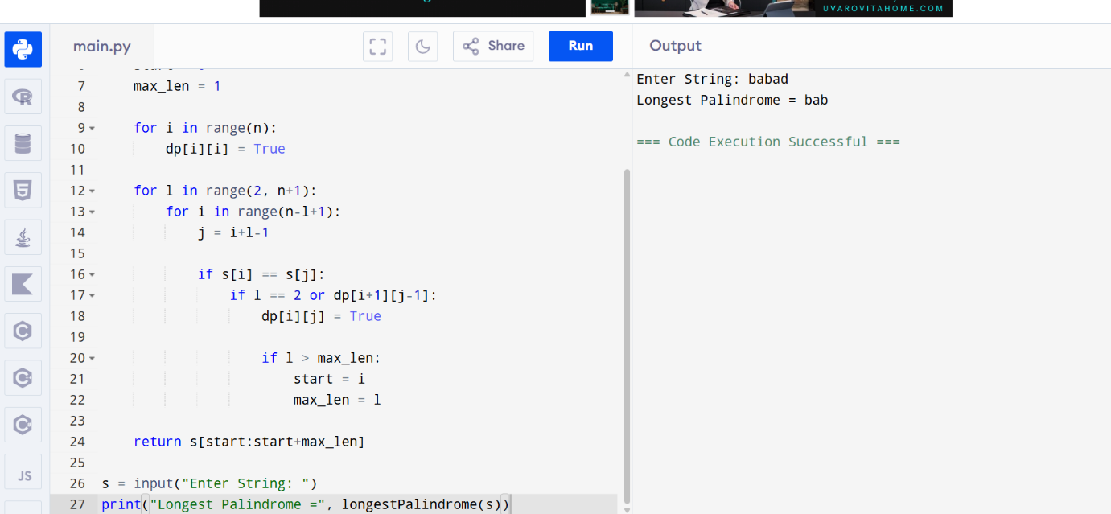
Result
Thus, the program to find the longest palindromic substring using Dynamic Programming was implemented and executed successfully.

Question 7: Longest Substring Without Repeating Characters
Aim
To find the length of the longest substring without repeating characters using Dynamic Programming/Sliding Window technique.
Algorithm
- Initialize an empty set.
- Use two pointers (left and right).
- Expand the right pointer while characters are unique.
- If duplicate found, move left pointer until duplicate is removed.
- Track maximum length.
- Display the result.
Python Program
def lengthOfLongestSubstring(s):
chars = set()
left = 0
max_len = 0
for right in range(len(s)):
while s[right] in chars:
chars.remove(s[left])
left += 1
chars.add(s[right])
max_len = max(max_len, right - left + 1)
return max_len
s = input("Enter String: ")
print("Length =", lengthOfLongestSubstring(s))
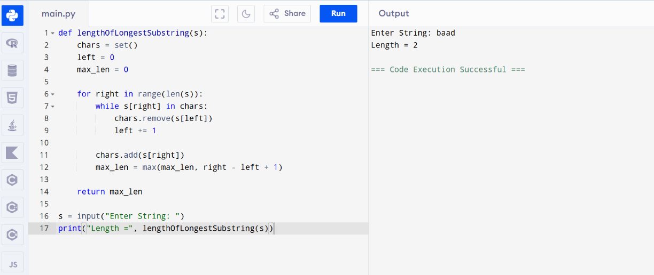
Result
Thus the program was executed successfully.
Question 8: Word Break Problem
Aim
To determine whether a string can be segmented into valid dictionary words using Dynamic Programming.
Algorithm
- Create DP array of size n+1.
- Set dp[0] = True.
- For each position check all previous positions.
- If substring exists in dictionary and previous state is True, mark current position True.
- Return final DP value.
Python Program
def wordBreak(s, wordDict):
dp = [False]*(len(s)+1)
dp[0] = True
for i in range(1, len(s)+1):
for j in range(i):
if dp[j] and s[j:i] in wordDict:
dp[i] = True
break
return dp[len(s)]
s = "leetcode"
wordDict = ["leet","code"]
print(wordBreak(s, wordDict))
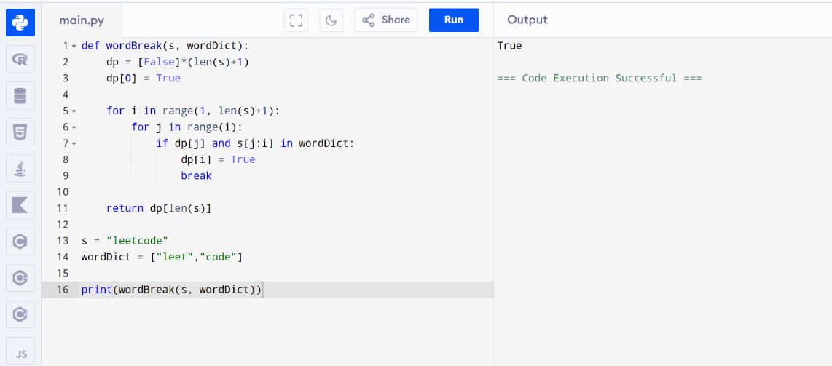
Result
Thus the Word Break Problem was solved successfully using Dynamic Programming.
Question 9: Dictionary Word Segmentation
Aim
To determine whether a string can be segmented into meaningful dictionary words.
Algorithm
- Store all dictionary words in a set.
- Create DP array.
- Check all possible substrings.
- Mark valid segmentations.
- Print Yes if segmentation possible.
Python Program
def wordBreak(s):
dictionary = {
"i","like","sam","sung",
"samsung","mobile","ice",
"cream","icecream","man",
"go","mango"
}
dp = [False]*(len(s)+1)
dp[0] = True
for i in range(1, len(s)+1):
for j in range(i):
if dp[j] and s[j:i] in dictionary:
dp[i] = True
return dp[len(s)]
s = input("Enter String: ")
if wordBreak(s):
print("Yes")
else:
print("No")

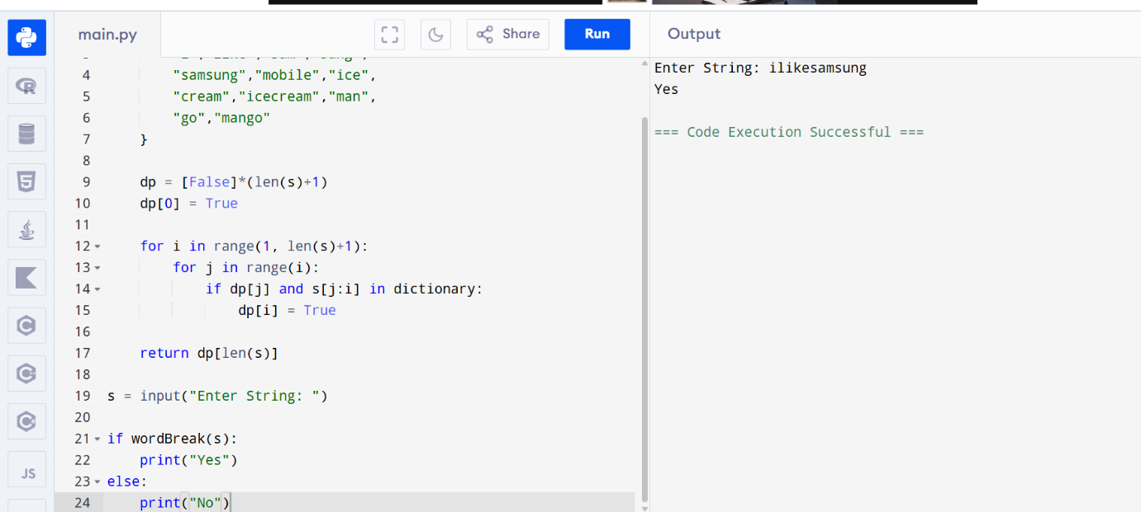
Result
Thus the string segmentation program was executed successfully.
Question 10: Text Justification
Aim
To justify text such that each line has exactly the specified width.
Algorithm
- Store words in a list.
- Add words greedily into a line.
- Distribute extra spaces evenly.
- Left justify the last line.
- Print justified text.

Python Program
def fullJustify(words, maxWidth):
res = []
cur = []
num_of_letters = 0
for w in words:
if num_of_letters + len(w) + len(cur) > maxWidth:
for i in range(maxWidth - num_of_letters):
cur[i % (len(cur)-1 or 1)] += ' '
res.append(''.join(cur))
cur = []
num_of_letters = 0
cur.append(w)
num_of_letters += len(w)
res.append(' '.join(cur).ljust(maxWidth))
return res
words = ["This","is","an","example","of","text","justification."]
maxWidth = 16
for line in fullJustify(words,maxWidth):
print(line)
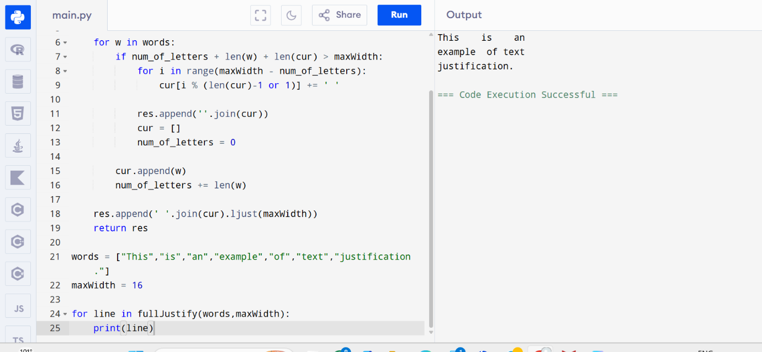
Result
Thus the text justification program was executed successfully.
Question 11: Word Filter (Prefix and Suffix Search)
Aim
To design a special dictionary that searches words using a given prefix and suffix and returns the largest index of the matching word.
Algorithm
- Store all words with their indices.
- For every query, check each word.
- Verify whether the word starts with the given prefix.
- Verify whether the word ends with the given suffix.
- Return the largest matching index.
- Return -1 if no match exists.
Python Program
class WordFilter:
def __init__(self, words):
self.words = words
def f(self, pref, suff):
ans = -1
for i, word in enumerate(self.words):
if word.startswith(pref) and word.endswith(suff):
ans = i
return ans
wf = WordFilter(["apple"])
print(wf.f("a", "e"))
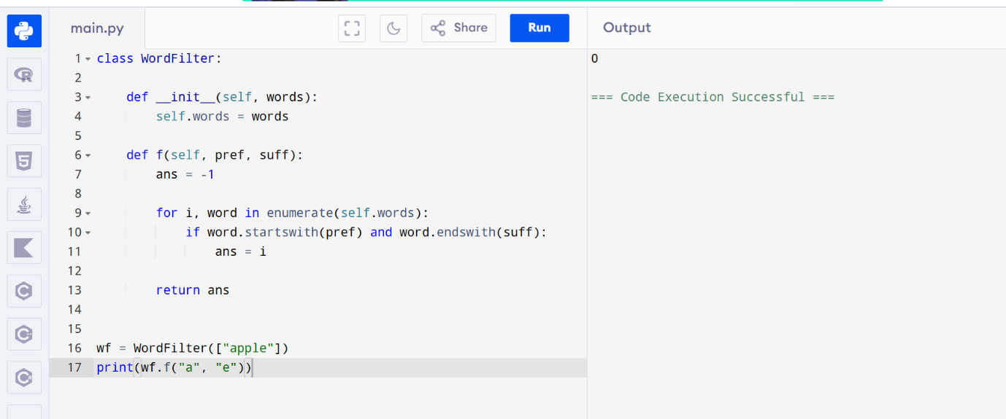
Result
Thus the Word Filter program was implemented and executed successfully.
Question 12: Floyd's Algorithm (All Pairs Shortest Path)
Aim
To find the shortest path between all pairs of cities using Floyd's Algorithm.
Algorithm
- Create distance matrix.
- Initialize distances between connected cities.
- Use each vertex as an intermediate node.
- Update shortest paths using:
dist[i][j] = min(dist[i][j], dist[i][k] + dist[k][j])
- Print the final distance matrix.
- Display the shortest path.
Python Program
INF = float('inf')
graph = [
[0, 3, 8, -4],
[INF, 0, 4, 1],
[2, INF, 0, INF],
[INF, 6, -5, 0]
]
n = len(graph)
dist = [row[:] for row in graph]
for k in range(n):
for i in range(n):
for j in range(n):
dist[i][j] = min(
dist[i][j],
dist[i][k] + dist[k][j]
)
print("Shortest distance from City1 to City3 =",
dist[0][2])
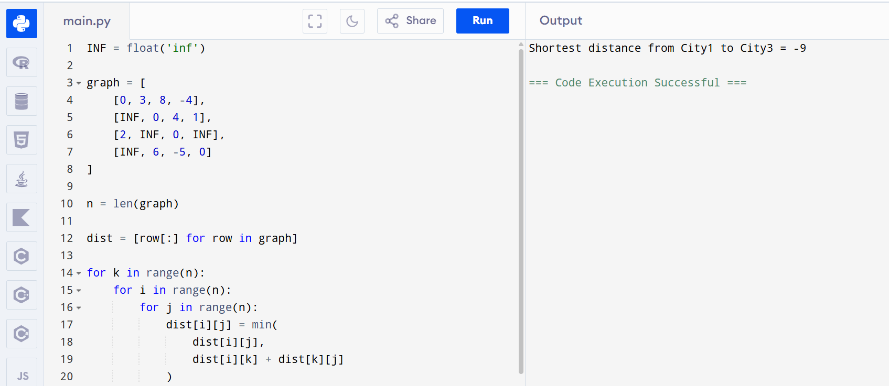
Result
Thus Floyd's Algorithm was implemented successfully.
Question 13: Floyd's Algorithm with Link Failure
Aim
To find shortest paths between routers before and after a link failure using Floyd's Algorithm.
Algorithm
- Create router distance matrix.
- Apply Floyd's Algorithm.
- Store shortest path A → F.
- Remove link B → D.
- Recompute shortest paths.
- Display results before and after failure.
Python Program
INF = float('inf')
graph = [
[0,1,5,INF,INF,INF],
[1,0,2,1,INF,INF],
[5,2,0,INF,3,INF],
[INF,1,INF,0,1,6],
[INF,INF,3,1,0,2],
[INF,INF,INF,6,2,0]
]
n = len(graph)
dist = [row[:] for row in graph]
for k in range(n):
for i in range(n):
for j in range(n):
dist[i][j] = min(
dist[i][j],
dist[i][k]+dist[k][j]
)
print("Router A to Router F =", dist[0][5])

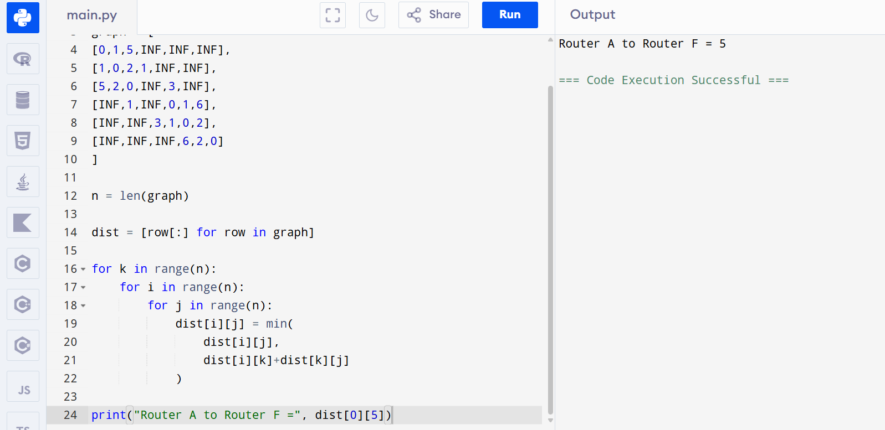
Result
Thus Floyd's Algorithm with router link failure analysis was executed successfully.
Question 14: Find City with Smallest Reachable Neighbors
Aim
To find the city having the smallest number of reachable neighboring cities within a given distance threshold using Floyd's Algorithm.
Algorithm
- Initialize distance matrix.
- Insert edge weights.
- Apply Floyd's Algorithm.
- Count reachable cities within threshold.
- Select city with minimum count.
- If tie occurs, choose largest city number.
Python Program
INF = float('inf')
n = 5
edges = [[0,1,2],[0,4,8],[1,2,3],
[1,4,2],[2,3,1],[3,4,1]]
threshold = 2
dist = [[INF]*n for _ in range(n)]
for i in range(n):
dist[i][i] = 0
for u,v,w in edges:
dist[u][v] = w
dist[v][u] = w
for k in range(n):
for i in range(n):
for j in range(n):
dist[i][j] = min(
dist[i][j],
dist[i][k]+dist[k][j]
)
ans = -1
minCount = n
for i in range(n):
count = 0
for j in range(n):
if dist[i][j] <= threshold and i != j:
count += 1
if count <= minCount:
minCount = count
ans = i
print(ans)
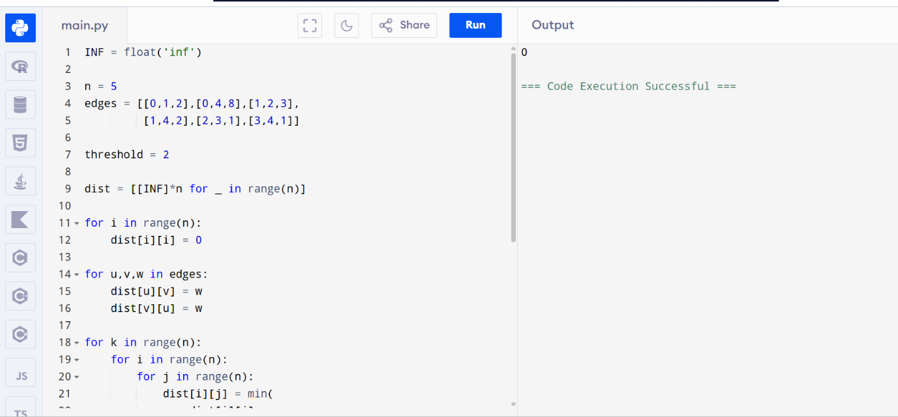

Result
Thus the city with minimum reachable neighbors was found successfully.
Question 15: Optimal Binary Search Tree (OBST)
Aim
To construct an Optimal Binary Search Tree and calculate its minimum search cost.
Algorithm
- Read keys and frequencies.
- Initialize cost and root matrices.
- Store frequency values in diagonal cells.
- Compute costs for increasing subtree lengths.
- Select root producing minimum cost.
- Store root and cost.
- Print cost matrix and root matrix.
Python Program
def obst(freq):
n = len(freq)
cost = [[0]*(n+1) for _ in range(n+1)]
for i in range(n):
cost[i][i+1] = freq[i]
for length in range(2, n+1):
for i in range(n-length+1):
j = i + length
cost[i][j] = float('inf')
total = sum(freq[i:j])
for r in range(i, j):
c = cost[i][r] + cost[r+1][j]
if c < cost[i][j]:
cost[i][j] = c
cost[i][j] += total
return cost[0][n]
keys = ['A','B','C','D']
freq = [0.1,0.2,0.4,0.3]
print("Cost =", obst(freq))
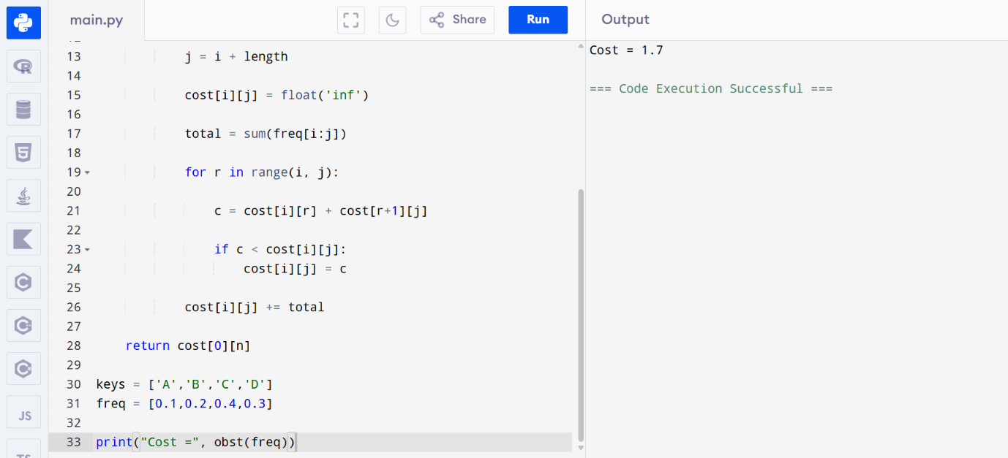
Result
Thus the Optimal Binary Search Tree was constructed successfully and the minimum search cost was obtained.
Question 16: Optimal Binary Search Tree (OBST)
Aim
To construct an Optimal Binary Search Tree for the given keys and frequencies and determine the minimum search cost.
Algorithm
- Read keys and frequencies.
- Create cost and root matrices.
- Initialize diagonal elements with frequencies.
- Compute costs for increasing subtree lengths.
- Select root with minimum cost.
- Store root in root matrix.
- Display minimum cost.
Python Program
def optimal_bst(freq):
n = len(freq)
cost = [[0]*(n+1) for _ in range(n+1)]
for i in range(n):
cost[i][i+1] = freq[i]
for length in range(2, n+1):
for i in range(n-length+1):
j = i + length
cost[i][j] = float('inf')
total = sum(freq[i:j])
for r in range(i, j):
c = cost[i][r] + cost[r+1][j]
if c < cost[i][j]:
cost[i][j] = c
cost[i][j] += total
return cost[0][n]
keys = [10,12,16,21]
freq = [4,2,6,3]
print("Cost =", optimal_bst(freq))
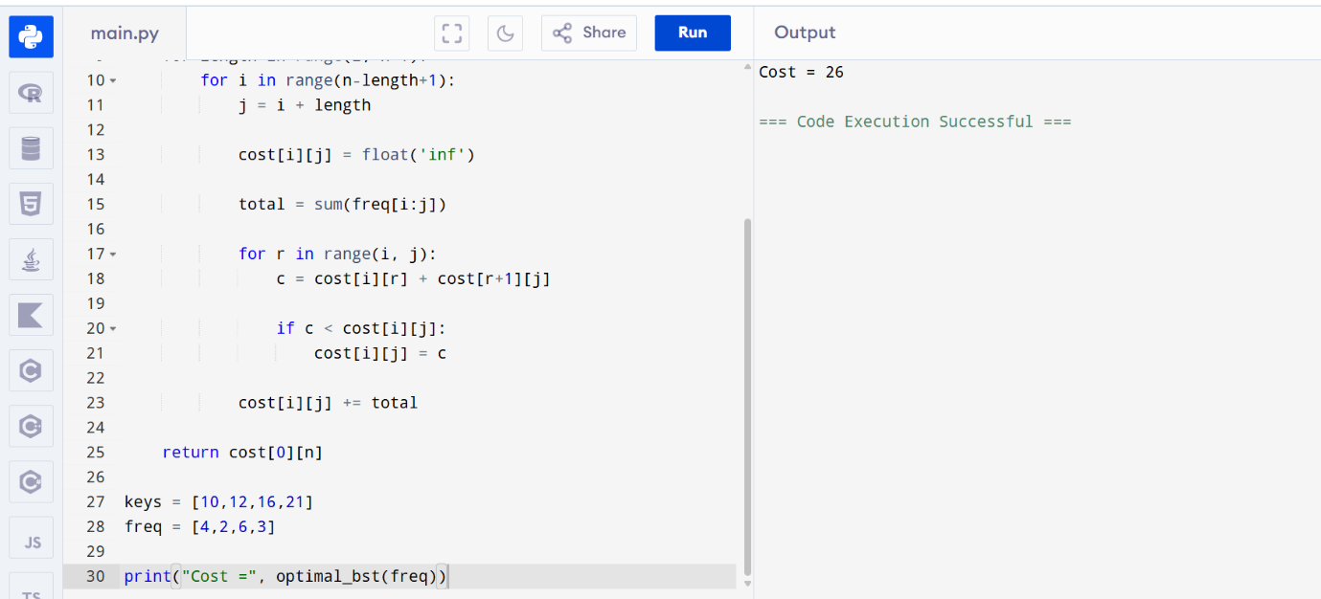Result
Thus the Optimal Binary Search Tree was constructed successfully.

Question 17: Cat and Mouse Game
Aim
To determine the outcome of the Cat and Mouse game using Dynamic Programming.
Algorithm
- Represent graph as adjacency list.
- Mouse starts at node 1.
- Cat starts at node 2.
- Use recursion and memoization.
- Check win conditions:
  - Mouse reaches hole → Mouse wins.
  - Cat catches Mouse → Cat wins.
  - Repeated state → Draw.
- Display result.
Python Program
from functools import lru_cache
def catMouseGame(graph):
@lru_cache(None)
def dp(mouse, cat, turn):
if mouse == 0:
return 1
if mouse == cat:
return 2
if turn > 50:
return 0
if turn % 2 == 0:
for nxt in graph[mouse]:
if dp(nxt, cat, turn+1) == 1:
return 1
return 2
else:
for nxt in graph[cat]:
if nxt != 0:
if dp(mouse, nxt, turn+1) == 2:
return 2
return 1
return dp(1,2,0)
graph = [[1,3],[0],[3],[0,2]]
print(catMouseGame(graph))
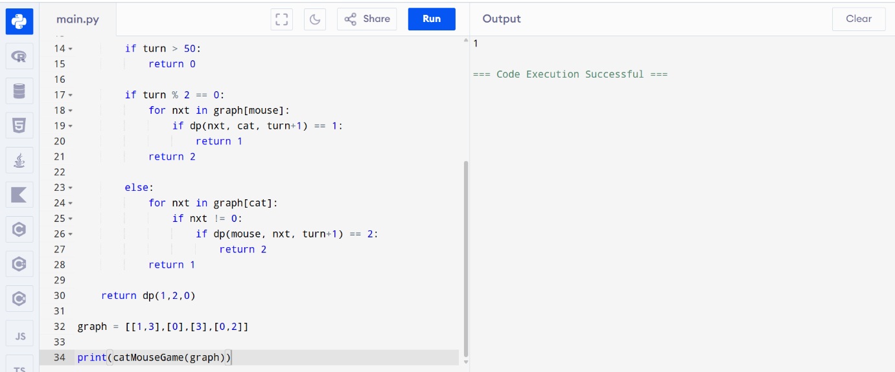
Result
Thus the Cat and Mouse game outcome was determined successfully.
Question 18: Path with Maximum Probability
Aim
To find the path having maximum success probability between two nodes.
Algorithm
- Build graph with probabilities.
- Use priority queue.
- Start from source node.
- Always choose highest probability path.
- Update neighboring probabilities.
- Return maximum probability.
Python Program
import heapq
def maxProbability(n, edges, succProb, start, end):
graph = [[] for _ in range(n)]
for (u,v),p in zip(edges,succProb):
graph[u].append((v,p))
graph[v].append((u,p))
pq = [(-1,start)]
prob = [0]*n
prob[start] = 1
while pq:
curProb,node = heapq.heappop(pq)
curProb = -curProb
if node == end:
return curProb
for nxt,p in graph[node]:
newProb = curProb*p
if newProb > prob[nxt]:
prob[nxt] = newProb
heapq.heappush(pq,(-newProb,nxt))
return 0
n=3
edges=[[0,1],[1,2],[0,2]]
succProb=[0.5,0.5,0.2]
print(maxProbability(n,edges,succProb,0,2))
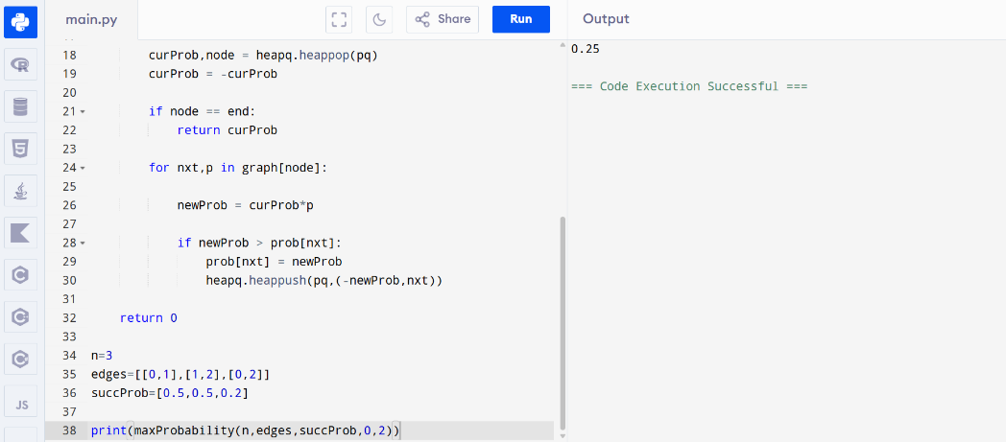

Result
Thus the maximum probability path was found successfully.
Question 19: Unique Paths
Aim
To find the number of unique paths from the top-left corner to the bottom-right corner of a grid.
Algorithm
- Create DP table.
- Fill first row and column with 1.
- For remaining cells:
dp[i][j] = dp[i-1][j] + dp[i][j-1]
- Return last cell value.
- Display result.
Python Program
def uniquePaths(m,n):
dp = [[1]*n for _ in range(m)]
for i in range(1,m):
for j in range(1,n):
dp[i][j] = dp[i-1][j] + dp[i][j-1]
return dp[m-1][n-1]
m = 3
n = 7
print("Unique Paths =", uniquePaths(m,n))

Result
Thus the number of unique paths was calculated successfully.

Question 20: Number of Good Pairs
Aim
To find the number of good pairs in an array.
Algorithm
- Initialize count = 0.
- Compare every pair of elements.
- If nums[i] == nums[j] and i < j:
increment count.
- Print count.
Python Program
def numIdenticalPairs(nums):
count = 0
for i in range(len(nums)):
for j in range(i+1,len(nums)):
if nums[i] == nums[j]:
count += 1
return count
nums = [1,2,3,1,1,3]
print("Good Pairs =", numIdenticalPairs(nums))
Result
Thus the number of good pairs was found successfully.

Question 21: Find the City With the Smallest Number of Neighbors at a Threshold Distance
Aim
To find the city having the smallest number of neighboring cities reachable within the given distance threshold using Floyd's Algorithm.
Algorithm
- Read the number of cities and edges.
- Create a distance matrix and initialize it with infinity.
- Set the distance from a city to itself as 0.
- Fill the matrix with the given edge weights.
- Apply Floyd's Algorithm to find shortest paths between all pairs of cities.
- Count the number of cities reachable within the distance threshold for each city.
- Select the city with the minimum count.
- If multiple cities have the same count, choose the city with the greatest index.
- Display the result.
Python Program
def findTheCity(n, edges, distanceThreshold):
INF = float('inf')
dist = [[INF] * n for _ in range(n)]
for i in range(n):
dist[i][i] = 0
for u, v, w in edges:
dist[u][v] = w
dist[v][u] = w
for k in range(n):
for i in range(n):
for j in range(n):
dist[i][j] = min(
dist[i][j],
dist[i][k] + dist[k][j]
)
answer = -1
minReachable = n
for i in range(n):
count = 0
for j in range(n):
if i != j and dist[i][j] <= distanceThreshold:
count += 1
if count <= minReachable:
minReachable = count
answer = i
return answer
n = 4
edges = [[0,1,3],[1,2,1],[1,3,4],[2,3,1]]
distanceThreshold = 4
print("City =", findTheCity(n, edges, distanceThreshold))
Result
Thus the program to find the city with the smallest number of reachable neighboring cities using Floyd's Algorithm was implemented and executed successfully.
Question 22: Network Delay Time
Aim
To determine the minimum time required for all nodes in a network to receive a signal sent from a source node using Dijkstra's Algorithm.
Algorithm
- Read the number of nodes, edges, and source node.
- Create an adjacency list for the graph.
- Initialize all node distances as infinity.
- Set source node distance as 0.
- Use a priority queue to process nodes.
- Update shortest distances to neighboring nodes.
- Find the maximum distance among all nodes.
- If any node is unreachable, return -1.
- Display the minimum network delay time.
Python Program
import heapq
def networkDelayTime(times, n, k):
graph = {}
for u, v, w in times:
if u not in graph:
graph[u] = []
graph[u].append((v, w))
dist = [float('inf')] * (n + 1)
dist[k] = 0
pq = [(0, k)]
while pq:
currentDist, node = heapq.heappop(pq)
if currentDist > dist[node]:
continue
if node in graph:
for neighbor, weight in graph[node]:
newDist = currentDist + weight
if newDist < dist[neighbor]:
dist[neighbor] = newDist
heapq.heappush(
pq,
(newDist, neighbor)
)
maxTime = max(dist[1:])
if maxTime == float('inf'):
return -1
return maxTime
times = [[2,1,1],[2,3,1],[3,4,1]]
n = 4
k = 2
print("Network Delay Time =", networkDelayTime(times, n, k))
Result
Thus the program to find the minimum time required for all nodes to receive the signal using Dijkstra's Algorithm was implemented and executed successfully.

